Highcharter for Finance in R

General syntax: Two charting function in the highcharter package:

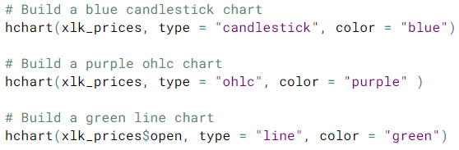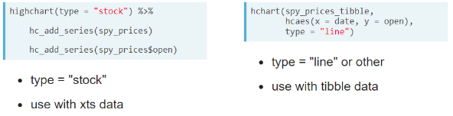

Data structures

* xts index(xts_object) shows the date index values

xts_object$column_name isolates the data in column_name

* wide tibble
* long tibble use dplyr functionality to get at data when in long tibble format

